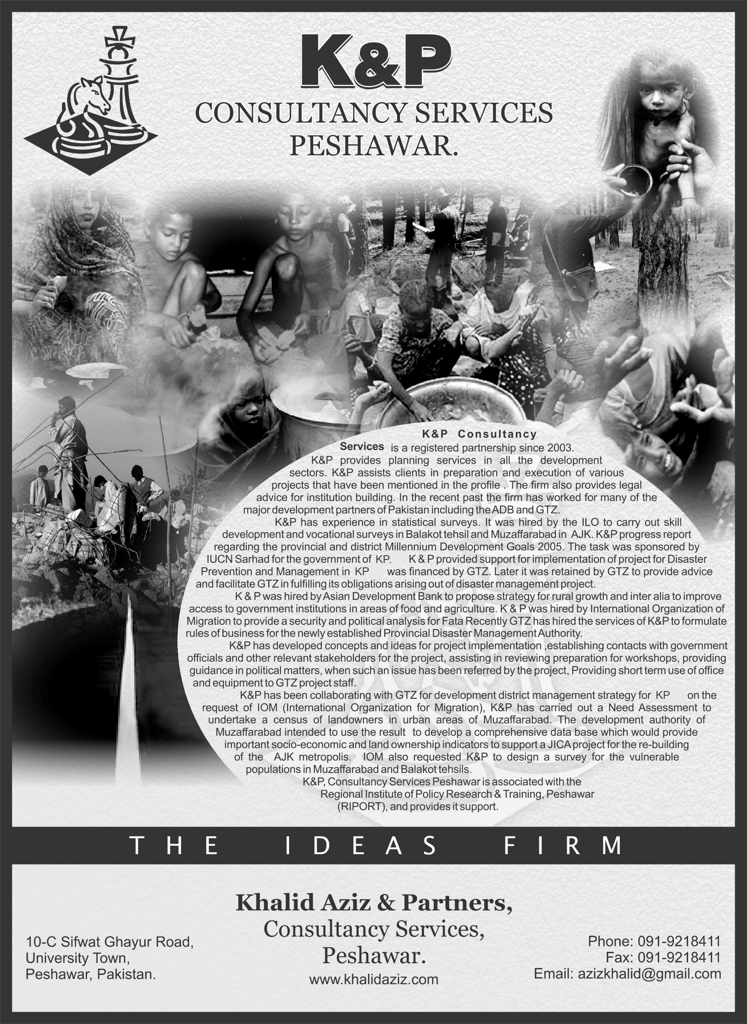

**INTRODUCTION**

**K&P Consultancy Services** is a Peshawar based registered partnership since 2003. It provides consultancy services in planning and evaluation of development activities in different sectors, including health, education, irrigation, power, drinking water and environment, besides creating institutional framework for public-private partnerships, governance reforms, community participation, poverty reduction, natural resource management, vocational training and road communication projects. K&P also provides monitoring and evaluation services for on-going projects and assists clients in interaction with government at various levels. K&P has the capacity to render strategic advice in the field of development planning in the FATAs. The firm provides legal advice for institution building and also undertakes surveys and focused group discussions for clients.

K&P, Consultancy Services Peshawar is associated with the Regional Institute of Policy Research & Training, Peshawar (RIPORT). RIPORT is a registered, non-profit organization formed in 2005 with its head office at 10-C, Sifwat Ghayur Road, University Town, Peshawar, Khyber Pakhtunkhwa. The Institute is presently operating in Khyber Pakhtunkhwa and the Federally Administered Tribal Areas (FATA). The NGO has capacity to provide policy analysis and formulation for reforms.

Transparency and accountability are core principles of the institute in managing its resources, which are to be utilized solely for promotion and fulfillment of its declared objectives.

In pursuit of the main objective RIPORT aims to focus on the following areas.

1. To render advice and recommendations to the governments based on objectively conducted policy research and analysis
2. To work for peace and welfare of the people by increasing understanding and bridging opposing thoughts.
3. To research and advocate appropriate conflict resolution mechanisms.
4. To impart training to build and enhance skills & capacities of public functionaries and non-governmental institutions in the area of conflict reduction, finance, development management and governance.
5. To create knowledge linkages with centers of learning and excellence in the region.
6. To advocate conflict reduction & peace, practicing of democratic norms, extension of provision of human rights through seminars, workshops and the media.

Details of assignments completed by the consultancy firm for its clients, both Government and national/ international non-governmental organizations are contained in the statement below:

**PROJECTS UNDERTAKEN BY K&P:**

**(MSI) Pakistan M&E Bridge**

**{June 4th to June 20th, 2014}**

* The task was to review and suggest improvements in data collection of three rounds of surveys conducted by MSI for preparation of a Stability Index for FATA and Malakand Division. Secondly to examine whether the findings are validated by the data?

**KP Local Governance under the LG ACT of 2013 read with 18th Amendment to the Constitution as Advisor Governance**

**{Jan 22nd to April 1st 2014}**

* To provide an analysis about;
  1. Accountability of various tiers of local government under the LG Act 2013
  2. Revised responsibilities of the provincial government after the 18th Amendment to the Constitution
  3. The oversight role of the provincial government under the LG Act 2013

**(Creative Associates) Preparation of KPG Program**

**{April 7th to 23rd 2014}**

* To assist the Creative Team in arranging relevant meetings;
* Assist in the technical design of the of the KP governance project
* Participate in the designing of the KP Governance project
* Arrange additional experts or staff if required
* Arrange short surveys when required.

**(GiZ) Institutional Analysis of Development Planning in Khyber Pakhuntkhwa**

**{Sept 2013 to Nov 2013}**

A research study on Institutional Analysis of Development Planning in Khyber Pakhtunkhwa funded by GiZ was conducted by K&P. Total duration of the consultancy was 2 months. The study was based on the following;

* Key Informant Interviews
* Discussion on Current Development Planning
* Identification of Gaps and Issues in Current Development Planning
* Review of Local Government Act 2013

**(DFID) Advisor to Coffey International on Peace Building Support to Post Conflict Need Assessment (PCNA)**

**{March 2013 to Sept 2013}**

* Advice and review of policy papers and participation in workshops
* Preparation of reports when requested
* Guiding project team

**(IUCN) Assisting FATA Secretariat in Integrating Environmental Sustainability into its Activities**

**{Feb 2012 – June 2012}**

* The mandate was implemented.

**(DFID) Oxford Policy Management Limited, Support for Preparation of Output-Based Budgets for Police Dept. of Khyber Pakhtunkhwa**

**{April 2012}**

K&P and Oxford Policy Management Limited (OPML), entered into a consultancy agreement to review the process of expenditure budgeting in the Police dept. and to propose changes.

**(DFID) Oxford Policy Management Limited, Support to Home Department**

**{April 2012}**

* For implementing output directed budget in its directorates

**(DFID) Oxford Policy Management Limited. Support to Preparation of Output-Based Budgets for Government of Khyber Pakhtunkhwa, Finance Department**

**{Feb- Mar 2012}**

K&P and Oxford Policy Management Limited (OPML), entered into a consultancy agreement for review of the reforms of Finance Department of Khyber Pukhtunkhwa government. This task was completed by K&P Consultancy Services.

**(NUPI) Swat: The Main Causes of the Breakdown of Governance and Rise of Militancy**

**{June 2010}**

RIPORT and NUPI (The Norwegian Institute of International Affairs, Oslo) agreed in Feb 2010 to conduct a statistical inquiry based on perceptions of households in Swat regarding what they considered to be the causes of breakdown of governance and the rise of militancy that took total control of Swat from July 2007 until Sept 2009, when the Pakistan military re-established the writ of the state. The task was successfully concluded and an analytical report was issued and is available.

**(US AID) Team Leader for US AID assisted “Creating a KP-FATA Investment Council,”**

**{April 2011-Dec 2012}**

RIPORT implemented the IPC an economic growth initiative proposed for the Khyber Pakhtunkhwa (KP) province and the Federally Administered Tribal Areas (FATA) of Pakistan. Following preliminary consultations with USAID Mission in Peshawar and the public sector reveal considerable interest in the creation of an Investment Promotion Council (IPC) for articulation, implementation and oversight of an economic growth agenda that improves the investment climate and induces capital flows into the region. The IPC was envisaged as a special purpose vehicle for integration of reform and economic growth initiatives of the KP, FATA and the private sector, and to align priorities that enable increased investment in the region.

**(US AID) Director Institution Building in Fata Capacity Building Program**

**{Feb 2008- Nov 2010}**.

While in this Mr. Khalid Aziz, Chairman RIPORT planned & implemented programs related to:

* *Economic Growth*
  + Creating framework for industrial investment in NWFP & Fata
  + Creating framework for implementation of RoZ
* *Strategic Communication*
  + Creating communication strategy to confront radicalism
  + Installation of FM stations to propagate peace
  + Content development for media
* *Civil Military Coordination*
  + Creating framework for stabilization policies in conflict areas
  + Introducing Civil Military coordination into teaching institutions
  + Creating framework for disarmament, de-weaponization & reintegration of militants.

**(GTZ) Consultancy on EAD Institutional Strengthening Appraisal Mission**

**{12 Sep-25 Sep 2009}**

Khalid Aziz assisted GTZ where the consultant explained the mandate, role and procedure in government organization for obtaining foreign assistance. To highlight in detail the procedure for governments and line departments to obtain foreign project assistance; including approvals from different government approval forums.

**Insurgency & Development in the North West Frontier Province & Tribal Areas of Pakistan, The Asia Foundation**

**{Dec 2007}**

This study was part of a larger work within the theoretical framework of the New Political Economy which states that positive institutional shift is essential in the process of achieving economic and social progress. Institutions which reward behavior leading to their strengthening are able to bring such a change. The study examined the security threat to institutions in the North West Frontier Province (NWFP) (now Khyber Pakhtunkhwa) and the tribal areas of Pakistan. The challenge of the Islamists in part arises out of distorted incentive structure based within the complex world of belief rather than experience.

**(ADB) National Agriculture Sector Strategy;**

**{June –Nov 2007}**

Khalid Aziz and Asian Development Bank (ADB), entered into a contract to carry out a detailed analysis where current mandates and responsibilities of different levels of the Government in agriculture and rural economic growth will be reviewed along with examination of ongoing work carried out by ADB (under the Decentralization Support Program and ASPL II), analyze the implications of devolution on agriculture in the four provinces, and highlight institutional constraints and opportunities.

**(IUCN) Support Program for FATA SDP Implementation;**

**{April –May 2007}**

Khalid Aziz and International Union for the Conservation of Nature (IUCN), entered into a contract to carry out a detailed analysis for reviewing of Key documents of FATA SDP, SPCS Reloaded etc. Understanding the shift of IUCNP from pure conservation focus to poverty environmental nexus. Studying of in detail the FATA SDP document to draw important linkages between the cross cutting initiatives and overall SDP strategic interventions.

**Main Streaming Disability into Government Activities (Christoffel** **Blindenmission and Pakistan Institute for Community Ophthalmology)**  
 **{Feb 2006}**

On 8th October, 2005, a massive earthquake struck northern Pakistan leaving thousands dead and homeless; countless others suffered from profound physical and mental trauma. The scale and complexity of this disaster - far greater than the 2004 Asian Tsunami - meant that disability concerns were at risk of being marginalized or overlooked. To help focus attention and mobilize action around the needs of disabled persons. Christoffel Blindenmission and Pakistan Institute for Community Ophthalmology held a one day meeting on 8 of February in Islamabad, four months after the devastating quake. The main goal of meeting was to strengthen disability inclusion in relief and development responses to the South Asia Earthquake. K&P was requested to recommend measures for implementing the above recommendations.

**Refinement of NWFP Poverty Reduction Strategy Paper (PRSP)**

**{20th February-July 2006}**

* K&P and International Union for the Conservation of Nature (IUCN), entered into a contract to carry out a detailed analysis for Refinement of NWFP Poverty Reduction Strategy Paper (PRSP)
* The objectives of this study are as under;
* Review the Provincial PRSP and identify gaps and relevant sectors that have been missed out in its formulation;
* Monetize the cost of all actions/initiatives on percent and rolling basis in order to provide a clear picture of the resource requirements for implementing the programme over the next five years i.e. 2005-06 to 2010-2011.
* Incorporate the potentials of economic development sectors like tourism, housing, industries, private sector development and natural resources for their significance in elevating poverty in the province.
* Review the Millennium Development Goals and to identify relationship between MDGs and provincial PRSP indicators leading to implementation of MDGs at provincial level.
* Incorporating environment and gender in PRSP as a cross cutting theme that clearly demonstrates the interdependency of both sectors with poverty in the over-all context of livelihood improvement as well as establishing linkage between the root cause of poverty, natural resource management, and the role of women in the existing natural resource management practices.
* Indicate the missing links between the national and provincial PRSP and capture the impact of Mid Term Development Framework 2005-10 and also to devise a mechanism for linking them.

**Construction of Battagram District Headquarters Hospital**

**{Feb-March 2006}**

The Pakistan Institute of Community Ophthalmology  (PICO), An International Eye Disease NGO,  Christoffel-Blindenmission of Germany and Light of the World (LOW),  hired the services of K&P to assist in the establishment of a district headquarter hospital at Battagram in lieu of the one destroyed by the earthquake.    K&P provided services for:

* Provide a clear roadmap to partners outlining roles and responsibilities that were duly accepted by all stakeholders.
* Obtaining clearance of ERRA for the designs for construction of DHQ Battagram including an eye and an orthopedic department which was provided funds by the Austrian government.

To obtain the approval of the Government of NWFP / ERRA in the form of an MOU permitting the construction of the hospital.

**Rail Link between Peshawar and Jalalabad**

**{Jan 2006}**

The Ministry of Railways requested K&P to undertake an initial concept study of a commercially viable rail link between Peshawar and Jalalabad. The concept paper including the track for a rail link was submitted to the ministry.

**(GTZ) Mandate, Role and Procedure in Government Organizations for Obtaining** **Foreign Assistance -**

**{September 2005}**

* K&P carried out a study / appraisal for GTZ with the following TORs.
* To explain the mandate, role and procedure in government organizations for obtaining foreign assistance.
* To explain in detail the procedure for governments and line departments to obtain foreign projects assistance including the approval of different forums.
* Identification of the powers and mandates of different forums for approval of foreign assistance.
* To explain the meaning of concept clearance, PC-1 to PC-5; the division of jurisdiction of the various departments like Planning Commission, Finance and EAD.
* The role of EAD in coordinating and monitoring of foreign assistance within and between Finance division Planning Commission, Federal and Provincial line agencies and district governments.
* To prepare relevant process flow diagrams as explanation for the approval processes.

**(GTZ) Enhancing Aid Effectiveness Through Institutional and Policy Reform of** **The Ministry of Economic Affairs And Statistics, Government of Pakistan. {September-October 2005}**

Khalid Aziz & K & P joined a 3 member team of experts from GTZ, the German technical assistance organization.  The objective was to appraise the request for grant assistance for enhancing aid effectiveness through institutional and policy reform.   The mission successfully made recommendations for;

* Strengthening EAD’s coordination capacity
* Training of EAD officials
* Support for the establishment of the Donor Coordination Cell and equipment.

**(IC) Project for Livelihood Improvement Institutional Set-Up n Dera Ismail Khan**

**{April-July 2005}**

The Project for Livelihood Improvement (PLI) and Non Formal Education Programme (NFEP) was launched in D.I.Khan, district of NWFP, by International Cooperation (IC), an International Swiss NGO in June and October 2003 respectively.

K&P was awarded a consultancy contract to provide solutions which would lead to the following results;

* To ensure a legal status for the project.
* To establish formal linkages with government to enhance collaboration
* To prevent political interference in the project.
* To create project ownership amongst the community.

K&P launched a team of experts that explored the potential of partnership with relevant Govt line departments by assessing their interests, current commitments and flexibility.  Potential government partners were consulted and recommendations were presented to IC’s steering committee thus completing the contract.

**Expenditure Management of Public Investment Projects**  **{Feb- March2005}**

World Bank and Issues and Policy Consultants (IPC) of Lahore, entered into a contract to carry out a study of Expenditure Management of Public Investment Projects for inclusion in the World Bank’s “NWFP Economic Report”. K & P conducted the study. The TORs of the project were as under;

* Rules/processes and practices being followed at the planning stage of public investment projects. The various steps involved in formulating public investment projects and involvement of other stake-holders, such as NGOs and the private sector.
* Identification of projects for inclusion in public investment budgets.
* Developing a system of forward estimates which projects the future cost implications of existing and proposed projects and programmes.
* Processes/steps to be followed for vetting of projects in public investment budgets.
* Study of the issues of institutional conflict of public investment projects between different levels of government, in particular between the Provincial Government and local Government for increasing effectiveness of public investments, particularly for growth enhancement and poverty reduction.
* Criteria used for selecting public investment projects.
* Indication of deficient checks and balances in the process.
* Identification of the steps/processes involved after the selection of projects to get approval for release of funds. Considering the constraints / issues at the stage of project implementation.
* Processes/practices for selection of contractors. Methods for reduction in “leakages”, pertaining to weak governance.
* Monitoring of projects during and after implementation and methods to improve M&E of projects.
* K&P studied all the processes and picked a number of projects in the core areas of education, health, roads, irrigation and regional development for a more detailed study. Its recommendations are a part of the published World Bank’s NWFP Economic Report (Dec 2005).

**International Organization for Migration (IOM), Out of Country** **Registration and Voting Program for Afghan Presidential Elections**

**{July to Oct 2004}**

K&P executed and performed a Service Contract for the International Organization for Migration (IOM) for provision of Regional National Advisory services in its Out of Country Registration and Voting program for the Afghan Presidential Elections, which were held on 9th October 2004. The United Nations Assistance to Mission to Afghanistan (UNAMA) was organizing these elections. This Programme was the biggest of its kind ever undertaken by an international organization in such a short period of time.  K&P completed the assignment to the satisfaction of IOM.

**Implementation of CAPBAP in FATA**

**{October2004}**

K&P developed a program called “Community Assistance Program for Border Areas Pakistan (CAPBAP)” for IoM to support the process of community strengthening through the implementation of rehabilitation and capacity building projects throughout the border districts of Baluchistan and NWFP.

**Leadership; Care and Growth Model** **{October 2004}**

K&P arranged and provided consultancy services to World Vision Pakistan an international nonprofit organization for a two days workshop for parliamentarians in NWFP under the Project.  The workshop was managed and organized by K&P.  The workshop was led by Mr. Etsko Schuetima, a leading leadership trainer from South Africa.

**Transforming BEFARe from a Project to an NGO** **{Nov to Dec2003}**

Basic Education for Afghan Refugees (BEFARe) is a bilateral project of the Federal Republic of Germany and Islamic Republic of Pakistan. The project came into being in 1989 to address the educational needs of millions of Afghan Refugees in the border regions of NWFP. BEFARe is considered as the world’s biggest emergency education project for refugees. A consultancy contract was signed between the GTZ and the K&P for transformation of BEFARe into an independent NGO. This was successfully concluded.